**Question 1:**

a) How should we open and close connection strings? b) Why we should use try catch when we open any connection string. c) Is there any way that we can eliminate the closing part, yet be sure that the connection is closed?

A) to open I used the command cn.Open()//Connection.open()//. Don’t need to close the Connection.

B) you will have objects that are not disposed of, so you would need to implement a try..catch..finally and dispose the objects within the finally block.

C) Yes. Since you are using [using](http://msdn.microsoft.com/en-us/library/yh598w02.aspx) statement

**Question 2:**

Why the return type of the ExecuteNonQuery is integer?

ExecuteNonQuery is an oddly named method that’s used to execute stored procedures

and SQL queries that insert, modify, or update data. The return value

will be the number of affected rows.

**Question 3:**

What is the use of defining the connection string in Web.config rather than using it in each page separately?

If we need to change the connection is only one file that you have to change do it

**Question 4:**

Name two different places that we can use “using” in ASP.NET:

Using *directives*, Using *statements*

**Question 5:**

Explain about application state, session state and cache object. Explain the cases that we should use any of these types. What can we use instead of cache object between application state and session state?

*Application state is a data repository available to all classes in an ASP.NET application. Application state is stored in memory on the server and is faster than storing and retrieving information in a database.*

*Caching, on the other hand, allows you to store objects in memory that require extensive server resources to create*

*Session is used for user specific information. Typically you would save username, user preferences like screen name*

*Contact*

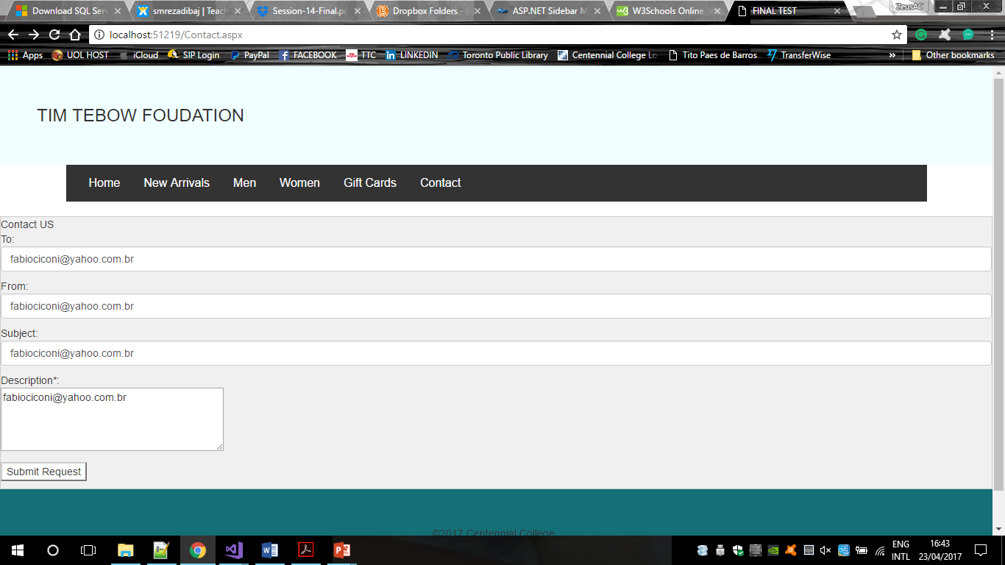

*Login:*

